***Project Report***

***On***

***“TOUR AND TRAVLES ”***

*Submitted*

*In partial fulfillment*

*for The award of the Diploma in*

# **Computer Science& Engineering**

# **In Department of Computer Science& Engineering**



**Submitted To: Guided By: Submitted By:**

Mr. Suneel kumar Mr. Rahul Singh Ankit Kumar Jangirl

HOD (CS) Dept. Of CS Roll No.:- 516089

**DEPARTMENT OF COMPUTER SCIENCE & ENGINEERING**

**SHEKHAWATI POLYTECHNIC COLLEGE,SIKAR**

**BOARD OF TECHNICAL EDUCATION RAJASTHAN,JODHPUR**

**2016-2017**

## CANDIDATE DECLARATION

I hereby declare that the work, which is being presented in the Report, entitled **Project Report on “Tour And Travels ”** in partial fulfillment for the award of Diploma in computer Science & Engineering” in Department of Computer Science &Engineering **and submitted to the Department of Computer Science & Engineering, Shekhawati Polytechnic college , Board Of Technical Education Rajasthan, Jodhpur** is a record of my own investigations carried under the help of Mr. Rahul Singh , Department of Computer Science Engineering, **, Shekhawati Polytechnic college , Sikar.**

I have not submitted the matter presented in this Report anywhere for the award of any other Degree.

**(Ankit Kumar Jangir ) ROLL NO. 516090**

**P.TECH 3RD YEAR (CS)**

**Shekhawati Polytechnic College, SIKAR**

**Name of Supervisor**

**Mr. Rahul Sir**

**Dept. of Computer Science**

# ACKNOWLEDGEMENT

The satisfaction that accompanies that the successful completion of any task would be incomplete without the mention of people whose ceaseless cooperation made it possible, whose constant guidance and encouragement crown all effort with success.

First and foremost I offer our sincere phrases of thanks with innate humility to **Mr. Rahul Singh** Assistant prof. of CSE Dept. Shekhawati Group of Institute & Technology and guide of my seminar for providing help whenever needed.

I wish to express my sincere thanks to all staff members of Department of CSE, SIET for their valuable suggestion.

**(Ankit Kumar Jangir)**

**ROLL NO. 516092 P.TECH 3RD YEAR (CS)**

**Shekhawati Polytechnic college , SIKAR**

**TABLE OF CONTENTS**

**1.ADMIN**

**a.Service add**

**b.Service update**

**c.Car add**

**d.Bus add**

**e.View suggestion**

**2.CUSTOMER(USER)**

**a.Search by vehicle type**

**b.Search by to**

**c.Search by from**

**d.Search by service**

**e.Seat status**

**f.Schedule**

**g.Booking**

**h.Suggestion**

**i.Cancel booking**

**ABSTRACT**

Title of the project**: Tour And Travel**

**1 INTRODUCTION & OBJECTIVE**

Tour And Travel is the travel agency which gives all the required facilities to their customers when they are ready to plan for any tour.

* 1. **PURPOSE OF THE PROJECT**

The purpose of developing web application “Tour And Travels” is to provide information to tourists who want to visit various locations and to know distance between specified places etc.,

**Existing System:**

In general if any user plans for any tour they must consult any traveling agency for purchasing package. At the same time the user has to do traveling reservations from source to destination and other travel reservations from destination to other places, this involves lot of manual work. For all these type of reservations must be done by user by standing lot of time in a queue. To avoid these problems to reduce the manual work to the user new project was developed i.e. Travel Management System

**Proposed system:**

Tour And Travel is the travel agency which gives all the required facilities to their customers when they are ready to plan for any tour. By using this portal the user can book any travel packages, they can reserve their tickets for any travel, they

can book hotels and also it provides help to the users.

**CHAPTER 1**

**Introduction**

**Project Introduction**

The Online Tours and Travel website is useful for the customers who like to book the Ticket online without going to booking office and dealing face to face. It provides the facility to the customers or the users to have complete information about the Tours and Travels at one place.

This website is very dynamic and very easy to understand, the interface of the website is very easy and anybody can *easily* work in our website, this website can provide all the description about the packages and tours such as tour images, description and some important information about the tours.

The online tours and travels website is also very useful because the customer don’t have to visit to booking office, he can easily book his ticket via this website and he can also pay the payment with two popular way of payment that is paypal and the credit card, so he can book ticket without any kind of harassment.

All the covered commitments and provided utilities are described in the proposed system.

The UML Diagram has been drawn which is useful to display the flow of the Process throughout the system so even an inexperienced people can easily get idea of the proposed system.

The “Testing” technique that we have followed is up to grade and it’s helpful in easily finding the error or bugs. Testing is a process necessary to be conducted by analyst to have the system build error-less. Testing is important for consistency purposes that is user cannot access beyond its limitation.

In our bibliography we have mentioned a list of all the Books Names including the Author Name, the website that we have used for our help in searching the data, with an objective of letting the user know that with these tools use we have been able to create a website for various purposes.

* **Registration Module** :

In this module the user can register himself and after the registration he can be the login user of the site, The main advantage of this module is that the customer who is not register with us, so he cannot book the tickets, If he wanted to book the tickets so first of all he have to register.

* **Suggestion Module:**

*In this module the user can suggest any kind of* suggestion ,To the owner of the site.

* **Admin Module:** The contain management system module is very dynamic module with the help of this module we can add several of pages in website, so to add the pages like,

1. Service add
2. Car add
3. Bus add
4. Service update
5. View suggestion

(Fig. 1.1.2 Block Diagram of admin Module)

**Admin module**

conformm

Service add

Car add

Bus add

Delete

conform

Delete

conform

delete

The following figure shows a block diagram of whole system including all features:

customer

New

Registration

Existing

Correct Username

& Password

Home

Contact us

booking

to

From

Welcome

page

suggestion

Seat status

service

Search by

(Block Diagram of whole System)

**CHAPTER 2**

**Request For Proposal**

.

* This is website based on the e-commerce. E-commerce means electronic commerce is generally considered to be the booking aspect of [e-business](http://en.wikipedia.org/wiki/E-business). It also consists of the exchange of data to facilitate the financing and hand to hand payment aspects of business transactions.
* Online Tour & Travel will work to booking its services and packages by online. There are several services and packages are available at the one place. As like the packages of Kerala, Goa and Kashmir And so on.
* If the new user are visited the site and wants to book the tickets. So first they have to register and then the user will able to book the tickets.
* Some other functionality of that site is that register user will change, its login information, Other module will also included as like the, Registration module, Admin module, Suggestion module.

**CHAPTER 3**

**Feasibility Study**

Feasibility study is carried out when there is a complex problem or opportunity. It is considered as the primary investigation which emphasizes on “Look before You Loop” approach to any project.

A Feasibility study is undertaken to determine the possibility of either improving the existing system or developing a completely new system.

**In feasibility study there are three types of study takes place:**

1. **Technical Feasibility Study :**

In this type of study the current technology in used in an organization is checked such as the existing software, hardware, and personnel staff to determine whether it will work for the proposed system or completely new ones is to be used.

* The technology that was important in developing a new system such as Development tools, back-end database system were available from within the organization.
* The proposed system is capable of adding, changing, enhancing the functionality, features etc.
* The proposed system is capable of handling large storage of data.
* The back-end and front-end technology has greater important for providing an accurate, error-free, frequencies of data to be used.

**2. Economical Feasibility Study:**

For proving that system developed is economical, the economical feasibility study takes place to check the cost of developing a system against the benefits that it provides. If the cost are less and benefits are more than we can define our system to be economically developed.

* User save time in searching for a particular product to be purchased by simply few mouse clicks.
* The registration processing is more speedier than the registered manually
* The saving of papers as all data are stored computerized.
* The record is of free of human errors as there is less chance of mistakes.

The above benefits are in terms of saving time, minimize errors and provide efficiency in work done.

**3. Operational Feasibility Study:**

The operational feasibility is concerned with the operatibility of the system after it has been installed. That is, some programmer may not like changes in their routine method of work or has fear that they will lose their peer group.

The following areas will have the operational feasibility in the proposed project:

* The organization has approved this system as their working system.
* The User of the system has accepted the proposed system as their new working system and realized the benefits of it.
* The system will work in a proper way after it has been installed and the installation process is easy to use.

CHAPTER 4

SYSTEM ANALYSIS

The object of the analysis activity in this project perspective is to develop structured system specifications of the needs and requirements specified by a user. It describes what the proposed system will do independent of the technology, which will be used to implement these requirements.

In System Analysis we have to determine whether the variation we observe is really from the customer responses to the survey and to determine how much of the variation is due to the questionnaire used to collect the user responses.

Requirement for statistically analyzing a system would involve a process to determine the variations from the central location which is imperative to analyze the measurement accuracy taking into consideration factors of stability and linearity.

The assigned modules are Profile, messages and friends. Profile is related with user’s information. Messages are used to sending or receiving messages to other users and Friends related with user’s friend their grouping and arrangement.

If an end user like Profile and other facility provided, it means it is acceptable otherwise discarded. We can measure the performance also by no. of connected persons to that site.

**CHAPTER 5**

**Software Requiement Specification**

An SRS is basically an organization's understanding of a user or potential client's system requirements and dependencies *at a particular point in time* (usually) prior to any actual design or development work. It's a two-way insurance policy that assures that both the client and the organization understand the other's requirements from that perspective at a given point in time.

**5.1 Introduction**

Every system might have existing system and might don’t have. Some system may be developed to perform on-line task to make the work of human being in an easier way as before existing system people might have worked on a manual basis. To complete a task through Manual basis is time consuming as well as it increases burden on the employee so for a better side to complete a task many of organizations are implementing on-line system. In early way the before there.

The existing system had been static. The Company follows a Online system for maintaining the Online Tour & Travels.

* Whenever admin want to manage all the modules in admin site then there no facility for that.
* The day-to-day entries are made Online into the book that has gotten all the relevant entries.
* In another problem in Existing System is that admin side. There are many admin are work. So the admin wants to give the specific permission to the control panel.

**5.2 Functional Requirements:**

* The client details are updated as when changes takes place and store updated values in database.
* The user’s inquiry, feedback and complaints are stored in database and in turn used to view details and updated frequently.
* The registration and login process are easier to perform.
* The client can put up their advertisement for users to view

**5.3 User Objective:**

Provide all functional requirements to user without any bug and with more security or permission.

**5.4 External User Requirement**

User should be able to his account only if he enters correct username and password. If any of both are wrong then user can’t login.

**5.5 System Features**

* Due to on-line booking of different tours and travel management. The system itself expands its business.
* As user can view different tour and travel on internet they get better idea of place and which place to book and choose the closest place to their desire area.
* In Tour & Travel system the client can get advantage as no more advertisements are required as it puts up its advertisements on Internet.
* By booking hotel and tour on internet the client can save his money by not going anywhere and by not taking the help of any source.
* By searching through city and travels the user can get all details of their tour planning and its related area just by sitting in their home using Internet.
* Client who is holding an account for booking detail can insert and delete its category as well as all data easily through its profile editing.

**5.4 Maintainability and Extensibility**

The code must be extensible and easy to understand as it is completely based on well defined functions, which can be extended at any time depending upon the requirements, and provide for easy enhancement of those functions.

5.6 Hardware Specification

Processor : Intel CORE i3

Speed : 1.4 G Hz

Cache : 256kB

RAM : 256 Mb

Hard Disk : 40Gb

5.7 Software Specification

Operating System: Windows 2007

Technology:Java(J2SE && J2EE)

* 1. Tools and technology

My sql:

‘MYSQL’ the most popular ‘open source’ SQL database management system is developed, distributed and supported by ‘MYSQL ‘AB’.’MYSQL AB’ is a commercial company, founded by the MYSQL developers that build its business by providing services around the ‘MYSQL’ database management system.

‘MYSQL’ is a database management system. A database is a structured collection of a data. It may be anything from a simple shopping list to a picture gallery or the vast amount of information in the corporate network. To add, access, and process data store in a computer database, you need a database management system such as ‘MYSQL ‘server. Since computer are very good at handling large amount of data, database, management systems play a central role in computing, as stand-alone utilities or as part of other application.

* MYSQL is Database server.
* MYSQL is ideal for both small and large application.
* MYSQL support standard SQL.
* MYSQL complies on a number of platforms.
* MYSQL is free to download and use.
* **Why use The MYSQL database server:**

The ‘MYSQL’ database server is very fast, reliable and easy to use. If that is what you are looking for, you should give it a try. ‘MYSQL’ server also has a practical set features developed in close cooperation with users. You can find a performance comparison of ‘MYSQL’ server with other database managers on our benchmark page. ’MYSQL’ was originally developed to handle large database much faster than existing solution and has been successfully use in highly demanding production environments for several years.

Java technology (j2se,j2ee):

Java is a programming language and computing platform first released by Sun Microsystems in 1995. There are lots of applications and websites that will not work unless you have Java installed, and more are created every day. Java is fast, secure, and reliable. From laptops to datacenters, game consoles to scientific supercomputers, cell phones to the Internet, Java is everywhere!

**Javascript** is not specifically HTML related, but interacts with HTML and DHTML when used in a browser. It’s a more traditional programming language, in that you can write a series of instructions to compute what kinds of actions should be taken based on various conditions, repeat things a variable number of times, and just generally take more complex and sophisticated actions. Small applications and games have been written entirely in Javascript.

The line between DHTML and Javascript can sometimes get blurry, but a rule of thumb I use is simple: DHTML is about the web page, period. The items on a web page, the events that a web page might want to act on (like moving your mouse over text), and the resulting changes to the web page that you might want to have happen resulting from those events (like changing the color of text). Javascript, however, is really web, and HTML, independent. It adds programming things like loops, and variables and functions.

**CHAPTER 6**

**DATA FLOW DIAGRAM**

a)DFD of login process

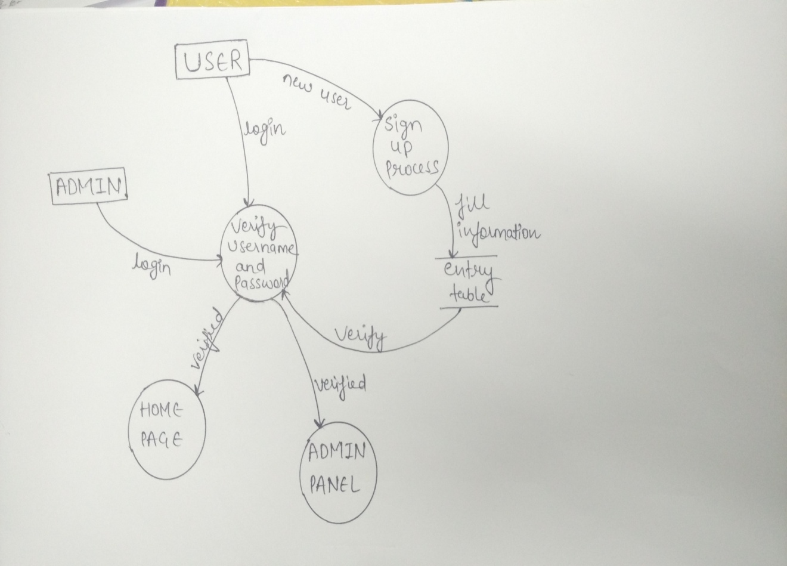

b)DFD of admin module

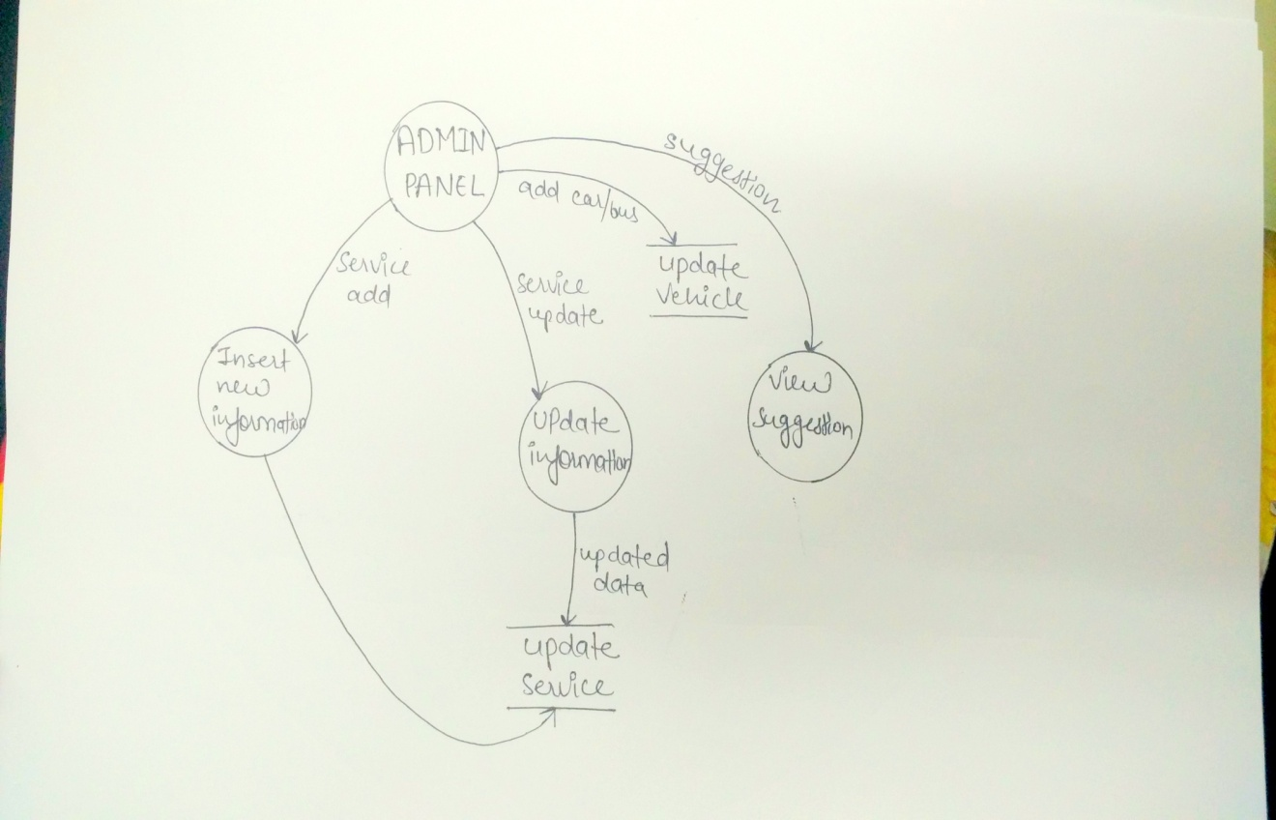

**c)DFD of user module**

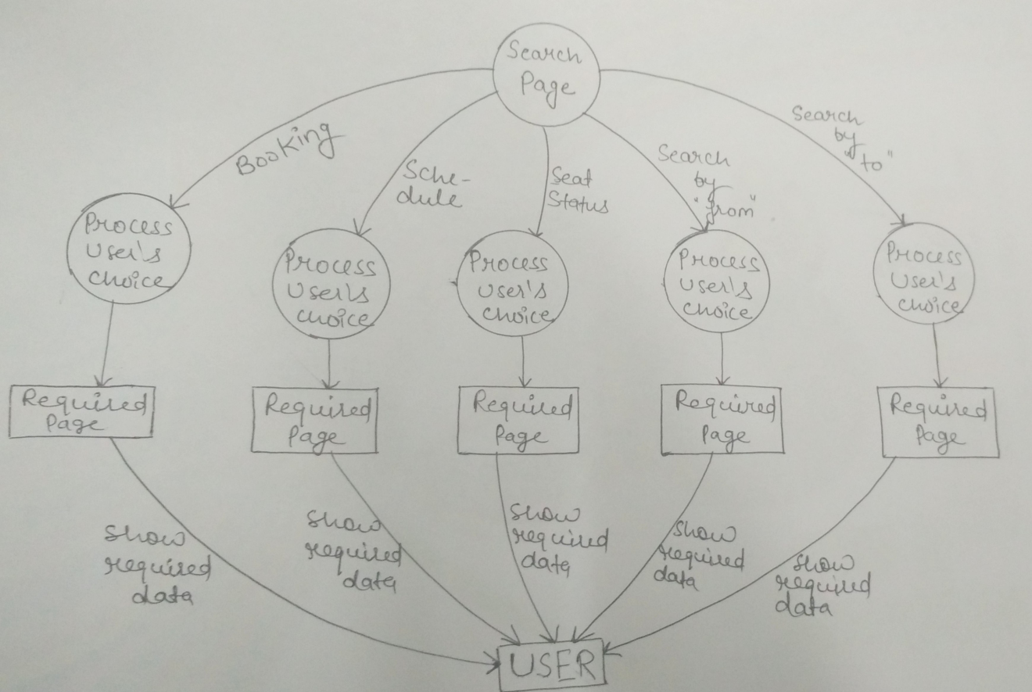

d)DFD of complete tour and

travel

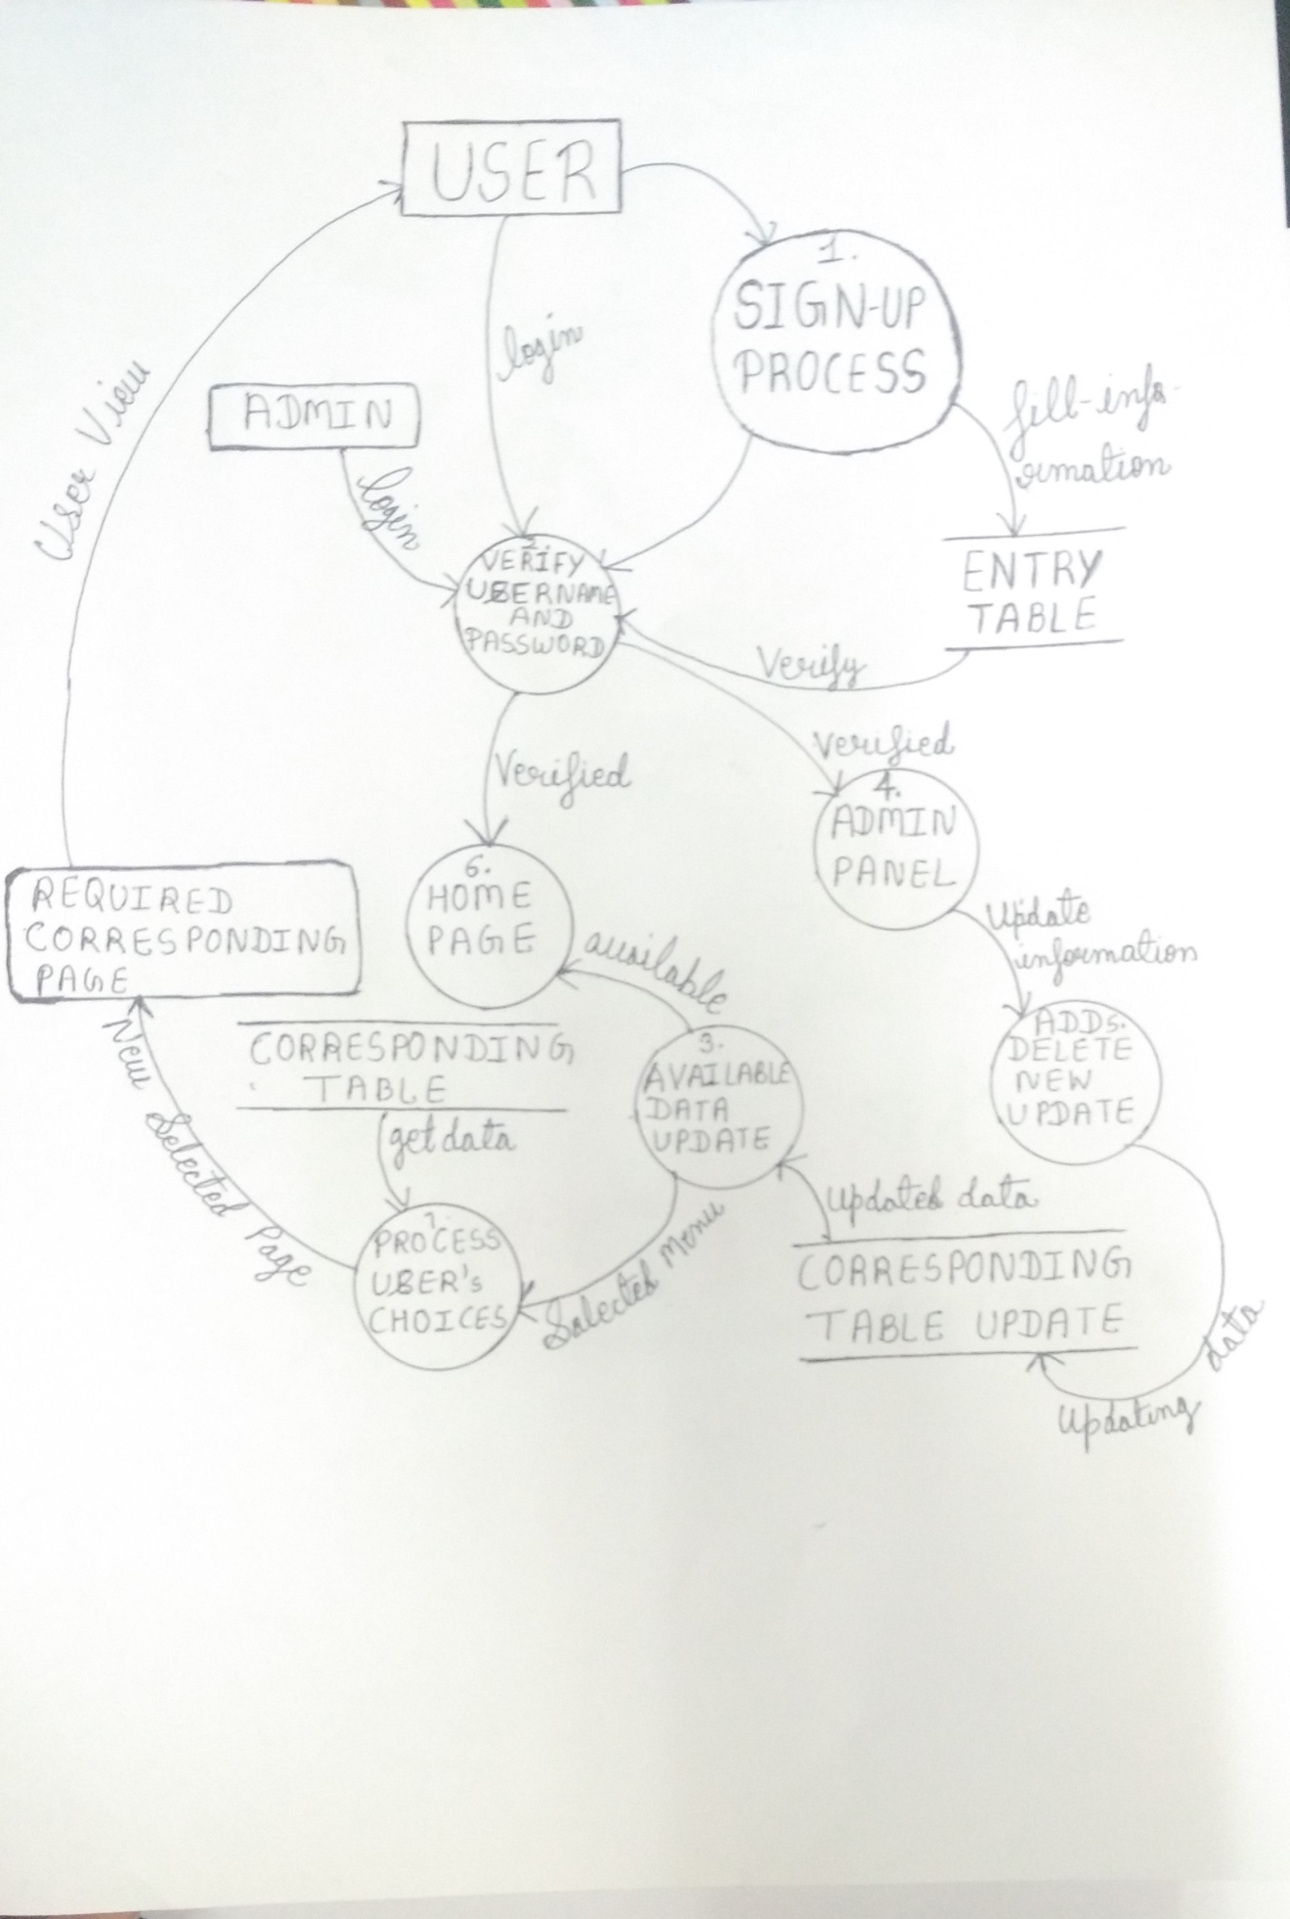

**CHAPTER 7**

**Detailed Design**

**7.1 Data Structure**

SQL Server 2005 used as back end in this project. The tables are as follow:

**Table name:Login**

|  |  |  |  |  |
| --- | --- | --- | --- | --- |
| **Field** | **Type** | **Size** | **Constrain** | **Description** |
| User_id | Integer | 4 | Auto_increment,  Primary key | UserID zzz |
| User_name | Varchar | 45 | Not Null | User have to give his name |
| Password | Varchar | 45 | Not Null | User have to give the password |

**Registration Details**

|  |  |  |  |  |
| --- | --- | --- | --- | --- |
| **Field** | **Type** | **Size** | **Constrain** | **Description** |
| name | Varchar | 30 | Not Null | First_Name |
| Email | Varchar | 20 | Not Null | Email |
| Password | Number | 10 | Not null | RetypePassword |

**Table name:Schedule**

|  |  |  |  |  |
| --- | --- | --- | --- | --- |
| **Field** | **Type** | **Size** | **Constrain** | **Description** |
| S_id | Integer | 4 | Primary Key | Service ID |
| sfrom | Varchar | 45 | Not Null | Source |
| sto | Varchar | 45 | Not Null | Destination |
| sfare | Float |  | Not Null | Charges |
| stime | Number | 45 | Not Null | Show Time |
| sstatus | Integer | 45 | Not Null | Show Status |
| stype | Varchar | 45 | Not null | Service type |

**Table name:Booking**

|  |  |  |  |  |
| --- | --- | --- | --- | --- |
| **Field** | **Type** | **Size** | **Constrain** | **Description** |
| id | Integer | 4 | Primary Key | Passenger ID |
| Name | Varchar | 45 | Not Null | Display the name of passenger |
| Age | Varchar | 45 | Not Null | Display the age of passenger |
| Email ID | Varchar | 45 | Not Null | Display the Email of user |
| BusNo | Varchar | 45 | Not Null | Display the Bus No |
| SeatNo | Varchar | 45 | Not Null | Dislay the Seat No |
| To | Integer | 45 | Not Null | Display the source city |
| From | Varchar | 45 | Not Null | Display the destination city |

**7.2 Entity-Relationship Diagram**

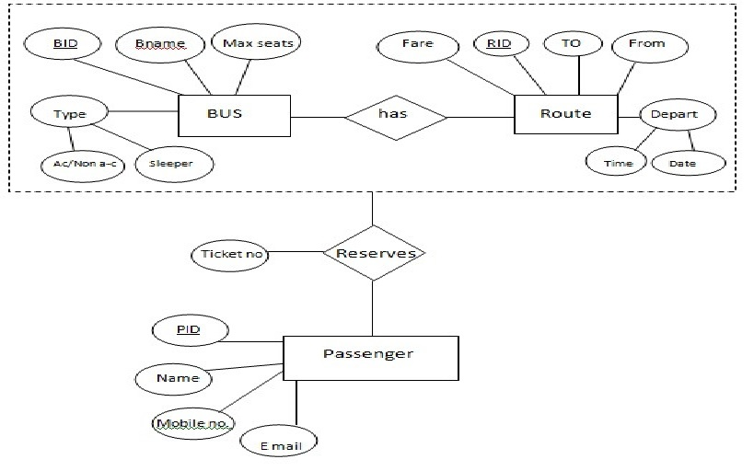

**7.2 Logic Design**

**7.2.1 Login Module:**

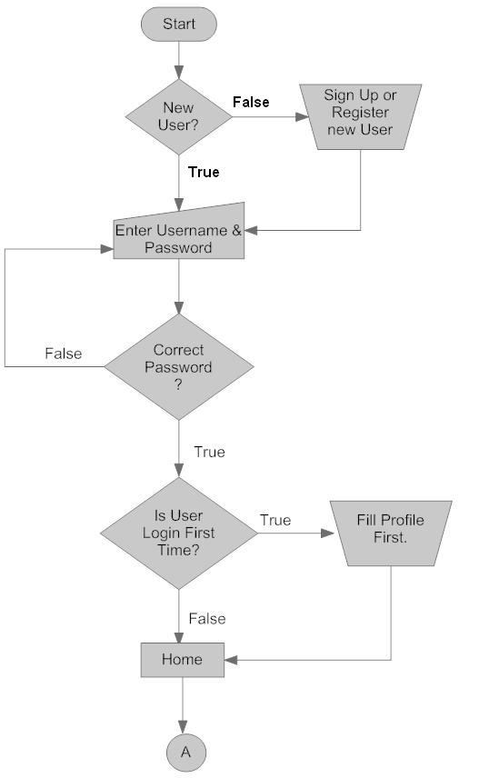

**7.2.2 booking module**

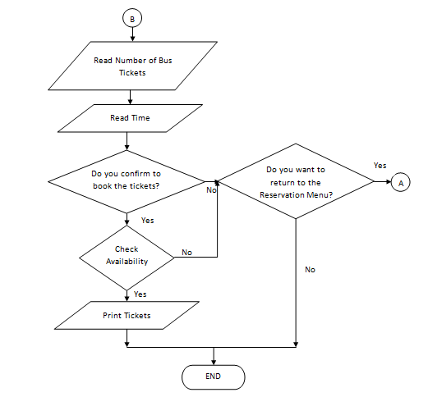

**7.3 User Interface Design**

**7.3.1 Tree Structure**

**7.3.2 Event Propagation**

**TOUR AND TRAVEL**

Admin Page

Login Page

User Page

View Suggestion

Username

Password

Suggestion

Edit

Search

**search**

Booking

Details

By

Vehicle type

Name

To

Age

From

Busno,seatno

**CHAPTER 8**

**Coding Standards**

The name of Module files included are:

* **File name: home.jsp**

Description: This is the home page which includes the description of “TOUR AND TRAVEL” agency .There is also a login page .So if anyone wants to visit the particular site then he/she has to first register.

* **File name: form.jsp**

Description: Contains the registration form of user with details like username , password , emailid .After having a registration only a user can visit the particular site.

* **File name: search.jsp**

Description: This includes the services for user like search by vehicle type ,search by to ,search by from, search by service, seat status suggestion, schedule , cancel booking.

* **File name: vehicle.jsp**

Description: By pressing on vehicle type on search.jsp we move on to vehicle.jsp where use can search for schedule by giving the vehicle type.

* **File name: to.jsp**

Description: By pressing on to on search.jsp we move on to to.jsp where use can search for schedule by giving the destination place.

* **File name:From.jsp**

Description: By pressing on from on search.jsp we move on to vehicle.jsp where use can search for schedule by giving the source place.

* **File name:service.jsp**

Description: By pressing on service on search.jsp we move on to vehicle.jsp where use can search for schedule by giving the vehicle type , to ,from.

* **File name: seatstatus.jsp**

Description: By pressing on seat status it displays the seat status of all the vehicle.

* Fi**le name: schedule.jsp**

Description: This shows the whole schedule of “TOUR AND TRAVEL” AGENCY with all the details like to , from, fare, bus id, timing ,etc.

* **File name: booking.jsp**

Description: This page allow the user to make booking by entering the detail which includes name, phoneno , age, emailid , busno , seatno , to , from.

* **File name: Suggestion.jsp**

Description: This page allow the user to put any suggestion regarding the facilities provided to them.

**Screen Layout**

* Home page

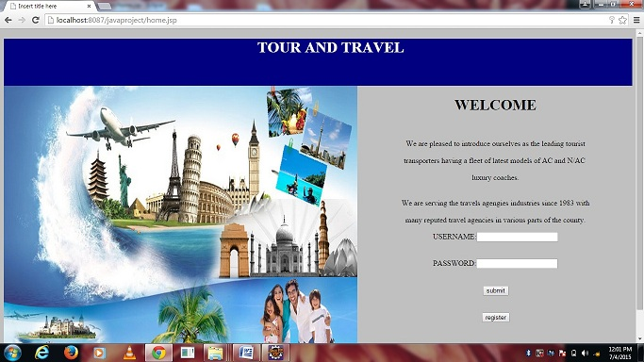

* **Admin Page**

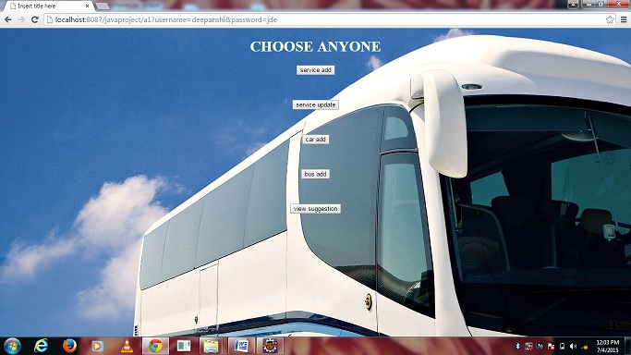

* **Add Service Page**

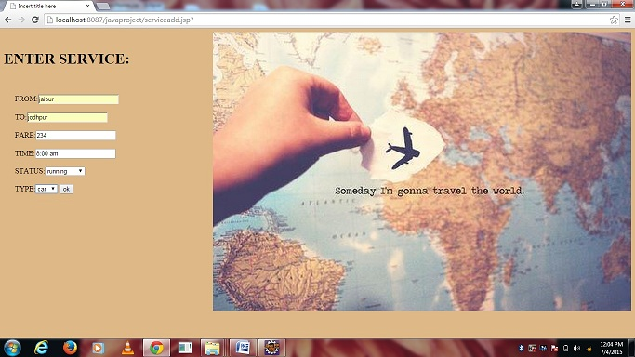

* **Car Add Page**

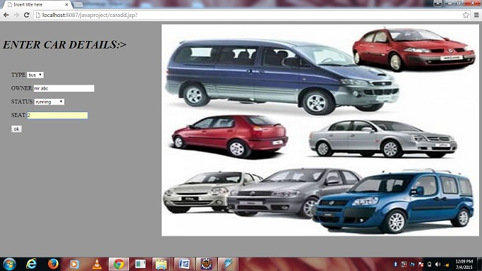

* **Update Service Page**

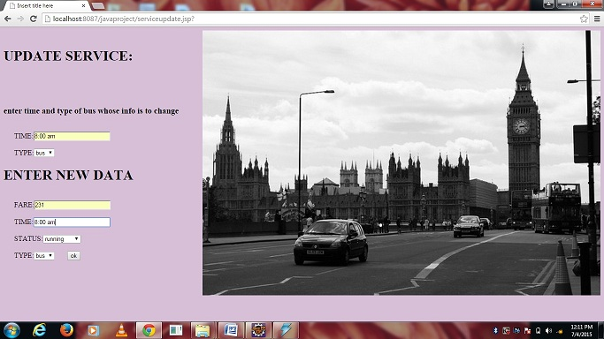

* **Bus Add Page**

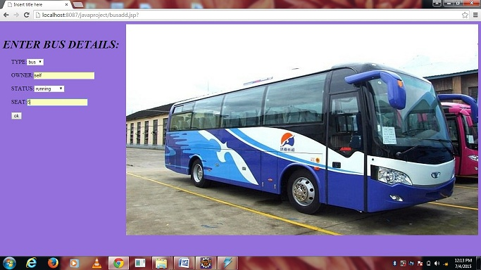

* **Regstartion Page**

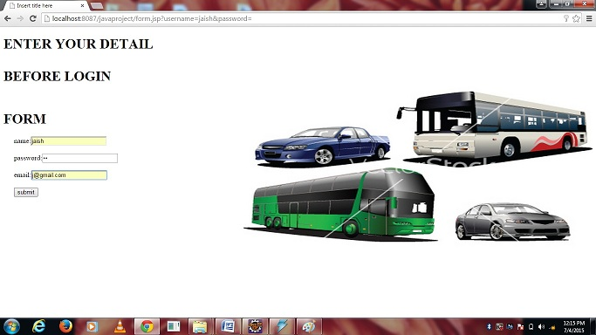

* **User Page**

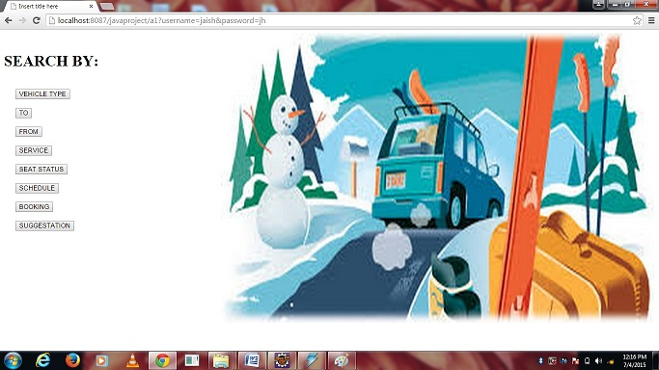

* **From Page**

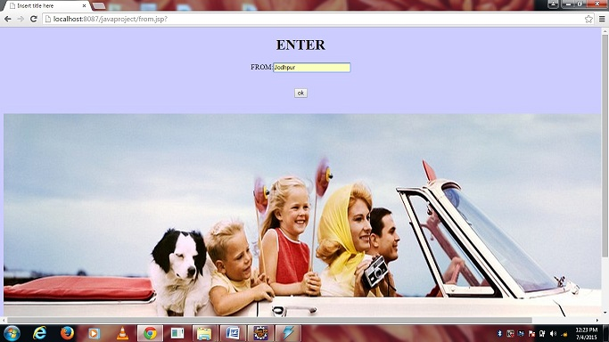

* **To Page**

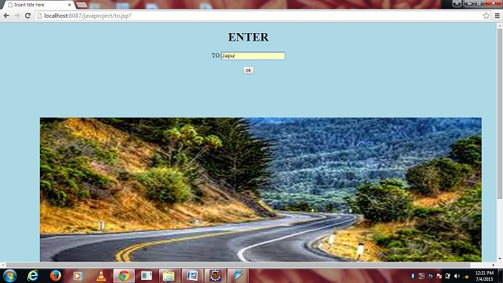

* **Vehicle Type**

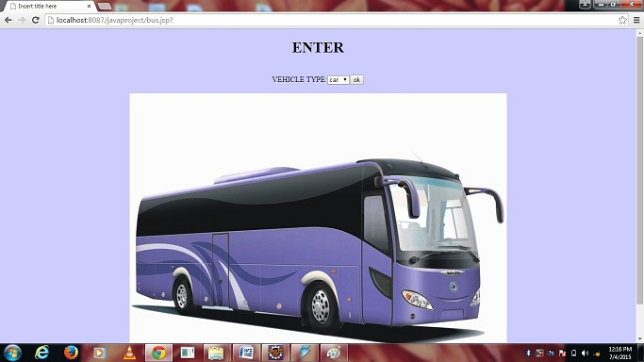

* **Booking page**

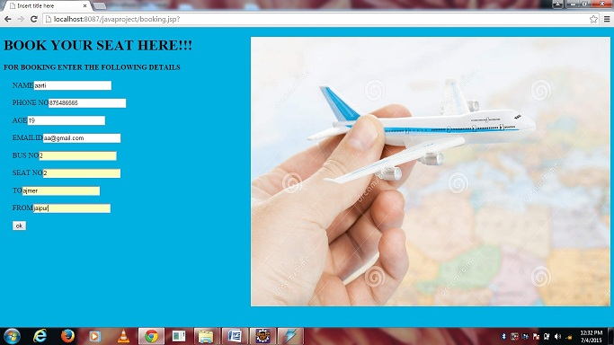

* **Suggestion page**

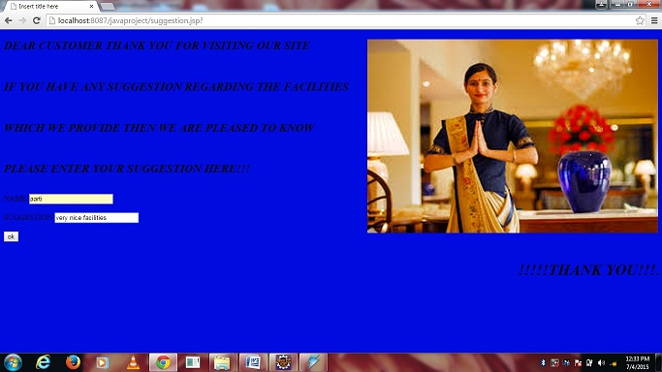

**CHAPTER9**

* **Testing**

Testing is vital to the success of the system. Once the source code has been completed the testing of system is performed to make the system error-free to produce the desired output. System testing makes a logical assumption that if all the parts of the system are correct, the goal of the system will be achieved.

Testing is considered as the Quality Assurance of software products for correctness, completeness, maintainability of software and its related documents. A good test is not redundant. Testing time and resources are limited. There is no point in conducting a test that has same purpose as another test. Every test should have a different purpose.

We have used following some strategies in testing a system:

* **Code Testing :**

The code testing is performed to check the logic of the entire path throughout the software to verify the logic used by the programmer. To perform code test we have developed a series of test cases that is helpful in catching the error if any available through the code

The code test does not depict the failure of system even if they find error or not. It does not give any conclusion whether it has worked according to a specification of system or it can be helpful in implementing the system easily. The code test defines only the code / program logical error of the system.

* **Specification Testing :**

To perform the Specification Testing, we have to examine the specification-documents that are provided by the analyst to verify that whether it works according to all included description about the various condition, type, way of operating and working in known and unknown situations.

Specification-documents include all the conditions, operation and method of working of the system. Thus, specification testing becomes an easy process by just testing according to a given description in it.

* **Unit Testing :**

Unit testing is performed on the independent module. In this testing a single module is tested to verify whether it works according to a specified logic, conditions to make the module error-free.

In unit testing we have created a test cases through which we have tested a single module and then integrated a number of modules and at last all modules are tested with an objective of removing error and the whole system is tested.

**System Testing :**

System Testing is undertaken to cover find weakness and strength of the system that was not found in earlier testing types. The entire system is tested to detect and correct errors. This includes forced system failure and validation of the total system as it will be by the user in the operational environment.

System testing begins with the lowest volumes of transaction with live data and to the maximum level of all data of the system. The total system is also tested for the recovery and fallback of major failures.

* **Storage testing :**

The specification of the capacity of the system has to be specified by the analyst at design time. The capacity measures in terms of number of records to be handled by the file in which the data to be stored and handled.

* **Performance Test :**

Performance Test is conducted before implementation stage occurs to check the time it takes to produce the output, reports, input, processing sequences of the system.

This test is conducted to determine the time taken to display the various requirements of the user.

* **Output consideration :**

The system is tested for the determination of correct output will it give and it should be according to the user’s requirements.

Various steps involved in output are described below:

* **Online-responses:** In an online system the output is more vital and it should not cause any hardship to its users. One way to test is to enter the transactions on as many CRT screens as would normally be used in peak hours and note the time taken to respond to each online function to establish a true relationship.
* **Volume:** This test involves entering the as many records as possible to verify that the hardware and software function effectively.
* **Stress testing:** The purpose of stress testing is to prove that the system does not malfunction and time factor plays an important role in completing the system within specified time.
* **Recovery and security:** A forced system failure is intentionally took place to test a backup recovery procedure. Inaccurate data are entered to test the unauthorized user to test the security of the system.
* **Usability documentation and procedure:** The usability test verifies the user-friendly environment of the system. This relates to normal operating and error-handling procedures of the system.